**Executive Summary**: RIVAL (Installation Risk Vulnerability Library) is a tool that presents a snapshot of installation COVID-19 vulnerability based on current conditions, disease vectors and human factors. It is intended to provide decision-makers with focused and relevant data by comparing and rank ordering installations by key risk factors.

**Source Information:**

Data Collection:

1. Confirmed Cases of COVID-19 (State and County)
2. Confirmed Deaths of COVID-19 (State and County)
3. Total COVID-19 Tests (State)
4. Department of the Air Force installation name, MAJCOM, location, and state
5. US county FIPS codes, location, state, population, land area
6. Hospital HHR / FIPS codes, location, bed/ICU bed availability
7. US Large Airports, state, location, passenger throughput
8. Social Vulnerability Index by County (demographics, emergency preparedness)
9. Social Distancing compliance metrics (state and county)

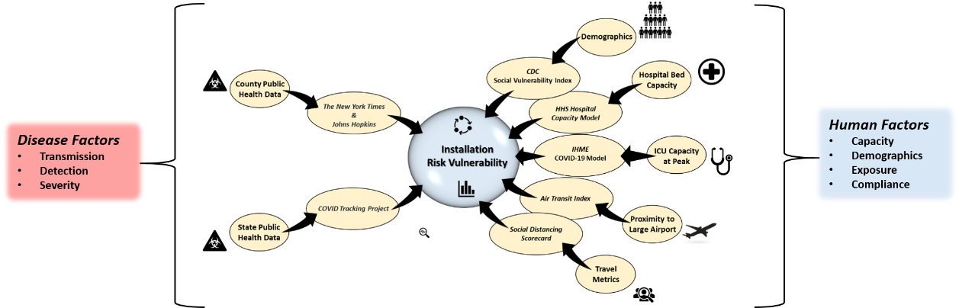

**Data Sources:**

1. **Johns Hopkins University**

JHU provides daily updated information every morning for cumulative cases and deaths from the COVID-19 in every county around the U.S.

<https://raw.githubusercontent.com/CSSEGISandData/COVID-19/master/csse_covid_19_data/csse_covid_19_time_series/time_series_covid19_confirmed_US.csv>

<https://raw.githubusercontent.com/CSSEGISandData/COVID-19/master/csse_covid_19_data/csse_covid_19_time_series/time_series_covid19_deaths_US.csv>

1. **COVID Tracking Project**

The COVID Tracking Project provides daily updated information every morning for cumulative cases and deaths from the COVID-19 in every county around the U.S.

COVID Tracking Project: <https://covidtracking.com/data/>

Excel data source: <https://covidtracking.com/api/v1/states/daily.csv>

1. **New York Times**

The New York Times data is the product of dozens of journalists working across several time zones to monitor news conferences, analyze data releases and seek clarification from public officials on how they categorize cases.

NY Times COVID-19 Data: <https://github.com/nytimes/covid-19-data>

Excel data source: <https://raw.githubusercontent.com/nytimes/covid-19-data/master/us-counties.csv>

1. **Harvard Global Health Institute**

HGHI, in conjunction with ProPublica, created a new model that builds on bed capacity data for each of 306 U.S. hospital markets to provide localized estimates of available beds, and beds needed to accommodate COVID-19 patients over the coming months.

<https://globalepidemics.org/our-data/hospital-capacity/>

1. **Institute for Health Metrics and Evaluation (IHME)**

The IHME fatality and hospitalization projections are recorded for every state, and many countries. Model updates occur typically 2-3 times a week**.**

<https://covid19.healthdata.org/projections>

1. **Center for Disease Control**

The CDC’s social vulnerability index (current as of 2016) weights local demographic, emergency response and medical capacity to combat and recover from an infectious disease outbreak.

CDC’s Social Vulnerability Index: <https://svi.cdc.gov/>

1. **Unacast**

Uncast created this interactive Scoreboard, updated daily, to empower organizations to measure and understand the efficacy of social distancing initiatives at the local level.

Social Distancing Scorecard: <https://www.unacast.com/covid19/social-distancing-scoreboard>

|  |  |
| --- | --- |
| **State Inputs** | ***Variable*** |
| Cases/100K | DS |
| Case Doubling Rate | CDS |
| Death Doubling Rate | DDS |
| Testing/Million | TS |
| 7-Day Compounded Case Growth Rate | CGRS |
| 7-Day Compounded Death Growth Rate | CDRS |
| Social Distancing Decrease in Mobility | CmS |
| Social Distancing Decrease in Non-Essential Visits | Cv |
|  | |
| **Installation+60 Miles Inputs** |  |
| Cases/100K | D60 |
| Case Doubling Rate | CD60 |
| Death Doubling Rate | DD60 |
| 7-Day Compounded Case Growth Rate | CGR60 |
| 7-Day Compounded Death Growth Rate | CDR60 |
| Air Travel Index | Cm60 |
| Hospital Beds Required | Beds |
| Hospital ICU Beds Required | ICU |
| ICU Peak Capacity Projection | Peak |
| % Population >65 | P65 |
|  | |
| **Installation (County) Inputs** |  |
| Social Distancing Decrease in Mobility | CmI |
| Social Vulnerability Index | SVI |
|  | |
| **Analysis** | **Equations** |
| Risk Vulnerability | RVF = Cf x Gf |
| * Capacity Factor | Cf =r(Beds) + s(ICU) + t(Peak) |
| * Growth Factor | Gf = Rf(NCfPf) |
| * + Prevention Factor | Pf = x(CmI) + y(Cv) + z(SVI) |
| * + Number of Cases Factor | NCf = In60i(D60 + (In60s * DS)) |
| * + Rate Factor | Rf = In60I(R60 + (In60s * RS)) |
| * + - 60 Mile Rate Factor | R60 = (1 - Df)(Cr60) + (Df)(Dr60) |
| * + - * 60 Mile Case Rate | Cr60 = a(CD60)+b(CGR60) |
| * + - * 60 Mile Death Rate | Dr60 = c(DD60)+d(CDR60) |
| * + - * Death Factor | Df = 1/(TS * P65) |
| * + - State Rate Factor | RS = e(CDS)+f(CGRS)+Df(DrS) |
| * + - * State Case Rate | CrS = e(CDS)+f(CGRS) |
| * + - * State Death Rate | DrS = g(DDS)+h(CDRS) |
| * + - * Death Factor | Df = 1/(TS * P65) |
| * + - State:60 Mile Insularity Factor | In60S = Log2(Cm60/CmState) - 1 |
| * + - 60 Mile:Installation Insularity Factor | In60I = Log2(CmI/Cm60)-1 |

|  |  |  |  |  |  |
| --- | --- | --- | --- | --- | --- |
| **60 Mile Case Rate Weighting** | | | **60 Mile Death Rate Weighting** | | |
| a | Case Doubling 60 | 1 | c | Death Doubling 60 | 1 |
| b | Case Growth 60 | 2 | d | Death Growth 60 | 2 |
| **State Case Rate Weighting** | | | **State Death Rate Weighting** | | |
| e | Case Doubling S | 1 | g | Death Doubling S. | 1 |
| f | Case Growth S. | 1 | h | Death Growth S. | 1 |
| **Prevention Weighting** | | | **Capacity Weighting** | | |
| x | Decrease Mobility | 2 | r | Beds | 1 |
| y | Decrease Non-E | 1.5 | s | ICU | 1 |
| z | SVI | 0.5 | t | Peak | 2 |